**Create & Populate API Testcase**

* Use created module to create Testcases in tosca
* Use auto fill value button to populate API TC
* Use autofill value button to copy default values into XML tc from keyboard

**API Testcase: 🡪**

* Best Practice to begin by renaming the elements with numerical Pre-fix, as they will be sorted in alphabetical order within API Scan
* Before exporting the API scan into tosca we should rename them with prefix

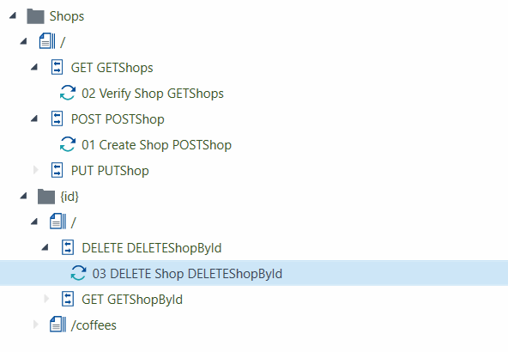

* Bcz services are sorted in alphabetical order
* Select the folder where we have to export all the services from API in Tosca

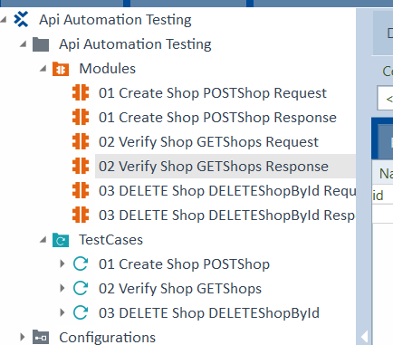

* Same name but it is creating 2 modules
* Request modules and TC will have the same name as the message name in the API Scan
* However, Tosca will automatically rename modules and testcase to add the suffix “Response” to the message name
* Use Prefix when naming Messages to easily match the request and response testcase pair

**Use Case: 🡪**

* We want to:
* Add a new coffeeshop to SUT database
* Verify it exists; hence the addition was successful
* Delete the coffeeshop just created from SUT database